Residential property transaction volume estimate and mortgage forecast for
February 2021

Duna House presents its monthly Transaction Number Estimate (DH-TE) and Mortgage Forecast below, showing that in February 2021 14,569 property transactions were concluded and residential mortgage contracts worth HUF 65-70 billion were signed in the whole of Hungary
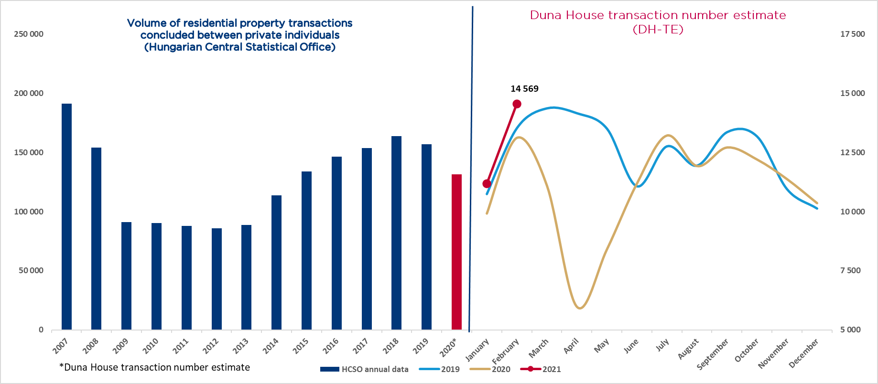
In February, the Hungarian residential property market achieved a new record: the number of transactions reached a ten-year high. The 14,569 sales transactions estimated by Duna House reflects a 11% stronger turnover compared to February 2020 and is 30% more than the already high January 2021 figures. The last time we saw transaction numbers exceeding 14,000 was in 2018 and 2019, on three occasions, and the record of the past ten years was 14,550 transactions in June 2016.
The increased demand triggered by new government home subsidies is still felt on the market and is starting to seep through to actual sales transaction numbers. Analysts believe this impetus may hold up through the spring months, resulting in a total transaction volume of 38-39,000 in the first quarter of the year.
As far as the property mortgage market is concerned, Duna House Finances estimates a volume of HUF 65-70 billion for the second month of the year, which is 5 billion less than it was a year ago but still 7% higher than in February 2019. Experience shows that mortgage market figures follow the property market trends with a few months’ delay. This is partly due to the character of the transactions and financial processes involved, and partly to the fact that on account of recent changes in subsidy rules consultations became necessary to ensure standardised interpretation of such changes. Therefore, the experts of Duna House Finances expect a significant rally on the property mortgage market in the coming months.

Budapest, 1 March 2021
Background info
The table below shows monthly transaction volume estimates of Duna House.

 | January | February | March | April | May | June | July | August | September | October | November | December
2018 | 10,918 | 12,869 | 13,426 | 13,180 | 13,967 | 13,098 | 14,246 | 13,869 | 12,787 | 12,689 | 12,033 | 9,721
2019 | 10,741 | 13,532 | 14,373 | 14,166 | 13,512 | 11,069 | 12,764 | 11,945 | 13,364 | 13,182 | 10,945 | 10,127
2020 | 9917 | 13,117 | 11,100 | 5971 | 8400 | 11,186 | 13,125 | 11,923 | 12,708 | 12,200 | 11 369 | 10,354
2021 | 11,185 | 14,569

Methodology behind DH-TE: Regardless of the time of year, the most important indicator of the real estate market is the annual number of sale transactions. The DH-TE figure is an estimate published by Duna House and it reflects interim approximate data. The estimate is based on the number of monthly property transactions brokered by Duna House and the estimated market share of Duna House. The estimate of the current monthly market share of Duna House is based on the following indicators: 1. Data published by the Hungarian Central Statistical Office on transactions among private individuals. Since the Statistical Office publishes data with several months’ delay, market share can be adjusted retroactively which also results in a more accurate estimate as well. Please note: After 2016 and as a consequence of the boom in newly-built apartments, pre-contracted purchase transactions appear in the statistics of the Statistical Office with a delay of several months or even one or two years, after the capital transfer tax has been levied, which results in anomalies in the statistics. 2. The number of Energy Certificates issued; 3. Subjective assessment based on other management information from Duna House Holding.
Please also note that DH-TE data cannot be used for defining the volume of transactions brokered by Duna House, or for estimating the business profit of Duna House Holding or for the drawing of any related conclusions.
Mortgage forecast: Figures published by Duna House Loan Center can primarily be used for quick trend forecasts; the National Bank of Hungary publishes the actual figures for the second last month at the beginning of each month.

