

Residential property transaction volume estimate and mortgage forecast for
February 2020
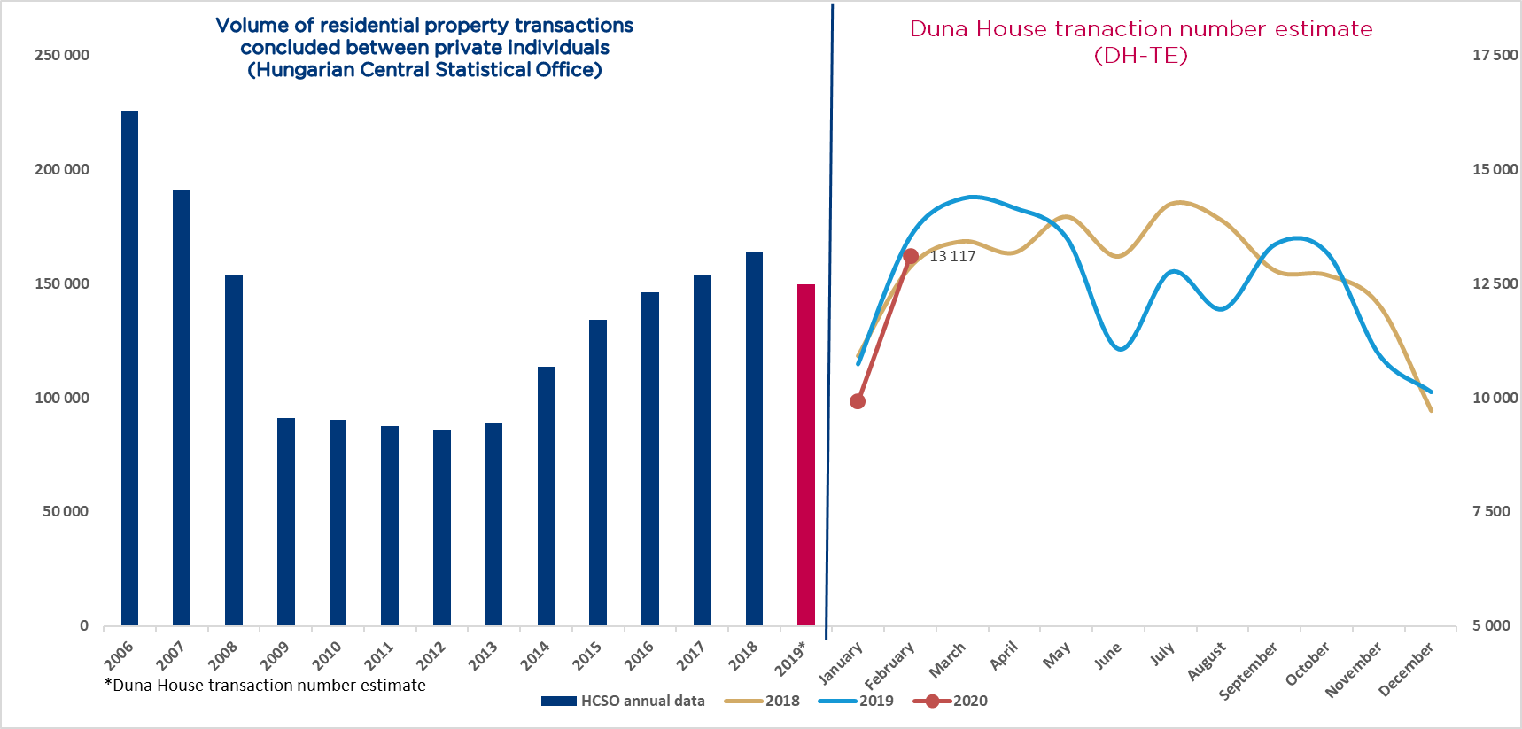
Duna House presents its monthly Transaction Number Estimate (DH-TE) and Mortgage Forecast below, showing that in February 2020 there were 13 117 property transactions concluded and HUF 73 billion residential mortgage contracts signed in the whole of Hungary.
Following the expectably weaker January transaction data the property market returned to the stronger figures seen in previous years, indicating a continued presence of solvent demand. The estimated 13+ thousand transactions in February are an almost 2 per cent increase over the same month in 2018 and a slight, 3 per cent decrease over February 2019. For the usually brisk spring season Duna House analysts still expect slightly increasing transaction numbers compared to the previous months, which will result in a stable, balanced residential property market.
As far as the mortgage market is concerned, it is still in an upswing compared to last year’s figures according to the forecast compiled by Duna House Loan Center. Data published by this independent loan agency the entire market saw mortgage contracts worth HUF 73 billion concluded in the second month of 2020. Compared to the factual figures of the National Bank of Hungary for February 2019 (HUF 62.6 billion) this means an increase of 16 per cent on a y/y basis.

Budapest, 1 March 2020
Background info
The table below shows monthly transaction volume estimates of Duna House.
 | January | February | March | April | May | June | July | August | September | October | November | December
2018 | 10 918 | 12 869 | 13 426 | 13 180 | 13 967 | 13 098 | 14 246 | 13 869 | 12 787 | 12 689 | 12 033 | 9 721
2019 | 10 741 | 13 532 | 14 373 | 14 166 | 13 512 | 11 069 | 12 764 | 11 945 | 13 364 | 13 182 | 10 945 | 10 127
2020 | 9 917 | 13 117

Methodology behind DH-TE: Regardless of the time of year, the most important indicator of the real estate market is the annual number of sale transactions. The DH-TE figure is an estimate published by Duna House and it reflects interim approximate data. The estimate is based on the number of monthly property transactions brokered by Duna House and the estimated market share of Duna House. The estimate of the current monthly market share of Duna House is based on the following indicators: 1. Data published by the Hungarian Central Statistical Office on transactions among private individuals. Since the Statistical Office publishes data with several months’ delay, market share can be adjusted retroactively which also results in a more accurate estimate as well. Please note: After 2016 and as a consequence of the boom in newly-built apartments, pre-contracted purchase transactions appear in the statistics of the Statistical Office with a delay of several months or even one or two years, after the capital transfer tax has been levied, which results in anomalies in the statistics. 2. The number of Energy Certificates issued; 3. Subjective assessment based on other management information from Duna House Holding. Please also note that DH-TE data cannot be used for defining the volume of transactions brokered by Duna House, or for estimating the business profit of Duna House Holding or for the drawing of any related conclusions.
Mortgage forecast: Figures published by Duna House Loan Center can primarily be used for quick trend forecasts; the National Bank of Hungary publishes the actual figures for the second last month at the beginning of each month.

